
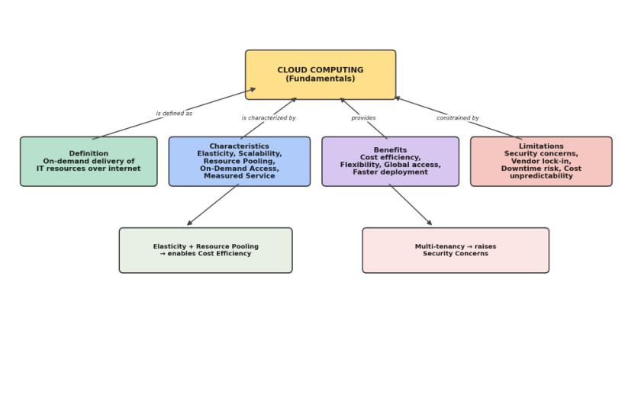
SIMATS ENGINEERING
ASSESSMENT TOOL 2: CONCEPT MAPPING
Cloud Computing and Big Data Analytics (CSA1520)
Student Name: | DAKSHIN.S | Reg. No.: | 192511431
Course Code: | CSA1520 | CO Assessed: | CO1
Total Marks: | 50 | Weightage: | 20%
Project Selected: | Smart Campus Management System | Dave's Taxonomy: | Imitation (L1)

Project Context: All tasks below are developed around the student's chosen Project — a "Smart Campus Management
System" covering student attendance (with an AI-based recognition module), fee management, notices, and analytics — as
the working example required by the assessment brief.
Concept Mapping Tasks (4 Concept Maps, as per Assessment Brief)
Each concept map below shows key nodes, labeled links, and a logical hierarchy, exactly as required by the four
Concept Mapping Tasks in the assessment.
Concept Map 1: Cloud Computing Fundamentals
Shows the definition, characteristics (elasticity, scalability, resource pooling, on-demand access, measured
service), benefits, and limitations of cloud computing, with labeled links connecting each branch back to the
central concept.
Figure 1: Concept Map 1 — Cloud Computing Fundamentals.
Concept Map 2: Evolution of Cloud Computing
Connects hardware evolution, internet/software evolution, distributed systems, and service delivery, showing how
each historical layer contributes to modern cloud computing.


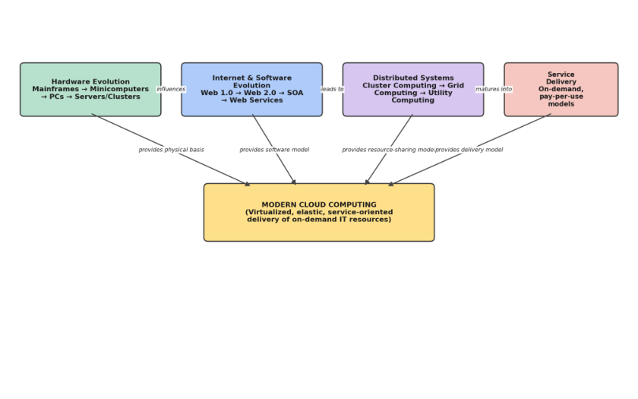
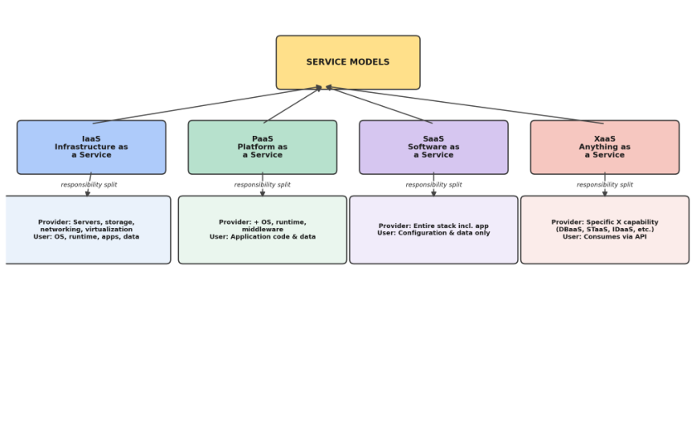
Figure 2: Concept Map 2 — Evolution of Cloud Computing.
Concept Map 3: Service Models
Maps IaaS, PaaS, SaaS, and XaaS against provider responsibilities and user responsibilities, showing the
shared-responsibility boundary for each model.
Figure 3: Concept Map 3 — Service Models and Responsibility Split.


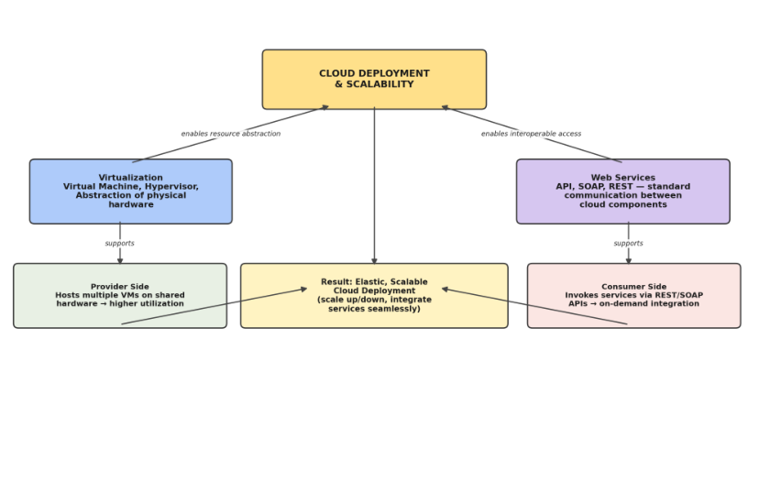
Concept Map 4: Virtualization and Web Services as Enablers of Cloud
Shows how virtualization (VM, hypervisor, abstraction) and web services (API, SOAP, REST) both support cloud
deployment and scalability, from both the provider side and the consumer side.
Figure 4: Concept Map 4 — Virtualization & Web Services as Enablers of Cloud.
Editable source note: In the actual submission, each map above should be recreated in draw.io / diagrams.net (or
an equivalent permitted tool) and saved individually, e.g. CSA15_CO1_AT2_192425341_Concept_Map1.drawio
through _Map4.drawio, with PNG/PDF exports and the .drawio source files uploaded to the GitHub repository
and Google Classroom as required by the submission procedure.
Task 2A: Service Model Responsibility Matrix
The table below compares SaaS, PaaS, IaaS, FaaS/serverless, DBaaS, Storage-as-a-Service, Identity-as-a-Service,
and Monitoring/Logging-as-a-Service, showing the shared responsibility split and why each split fits the Project.
Service Category | Managed by Cloud Provider | Managed by Application Team | Why This Split Fits the Project
SaaS (e.g.,  email/collaboration) | Application, runtime, OS, servers,  storage, network | Only configuration & user data/content | Used only for campus email/notice  collaboration; no need to manage code.
PaaS (App hosting for  backend) | Runtime, middleware, OS, servers,  storage, network, scaling | Application code, business logic, data model | Backend API for attendance/fees is  deployed without managing servers,  speeding delivery.
IaaS (Compute for AI  module) | Physical hardware, virtualization,  network, storage | OS patches, runtime, AI model code,  libraries | The attendance-recognition AI module  needs custom GPU/compute control, so  IaaS gives flexibility.
FaaS / Serverless  (Notifications) | Servers, runtime, scaling, execution  environment | Function code, triggers, event logic | Notification dispatch is event-driven and  infrequent, ideal for pay-per-execution  serverless.
Database-as-a-Service  (DBaaS) | DB engine, patching, backups,  replication, scaling | Schema design, queries, indexing, data governance | Reduces DBA overhead while the team  focuses on the campus data model.


Service Category | Managed by Cloud Provider | Managed by Application Team | Why This Split Fits the Project
Storage-as-a-Service  (Object Storage) | Durability, redundancy, storage  infrastructure | Bucket organization, access policy, file lifecycle rules | Stores student documents/media reliably  without managing disks.
Identity-as-a-Service  (IAM/IdP) | Authentication infrastructure, token  issuance, MFA engine | Role definitions, permission mapping, policy configuration | Ensures secure single sign-on for  students/faculty without building an auth  system from scratch.
Monitoring /  Logging-as-a-Service | Log storage, dashboard infra, alerting  engine | Alert thresholds, log queries, incident  response | Provides real-time visibility into system  health for the Project team without extra  infrastructure.

Task 2B: Cloud Service Decision Matrix
Project modules are mapped to the most relevant cloud services below, with justification, rather than forcing
every possible service into the design.
Project Module | Recommended Cloud Service | Justification
Authentication | Identity-as-a-Service (IAM / OAuth 2.0 IdP) | Centralizes secure login for students and faculty with minimal custom  development.
Frontend Hosting | SaaS-style static hosting / CDN | Delivers the web app globally with low latency and automatic scaling.
Backend / API Layer | PaaS (managed application service)  behind an API Gateway | Simplifies deployment and enables auto-scaling of the attendance/fees  API.
Database | Managed Database-as-a-Service  (relational) | Structured student, fee, and attendance records fit a relational schema  with managed backups.
Object Storage | Storage-as-a-Service (bucket storage) | Stores uploaded documents, ID photos, and reports durably and  cost-effectively.
Analytics / Logging | Managed analytics & logging service | Tracks attendance trends and system usage without building a data  pipeline from scratch.
Notification | Serverless / FaaS notification function | Sends event-driven SMS/email/app alerts only when triggered,  minimizing idle cost.
AI / Python Module | IaaS compute (VM with GPU) or  container service | Attendance-recognition model needs dedicated, configurable compute  resources.
Security | Cloud-native WAF + IAM policies | Protects APIs and data boundaries from unauthorized access and  common web attacks.
CI/CD | Managed CI/CD pipeline service | Automates build, test, and deployment for faster, reliable release cycles.
Backup | Automated snapshot / backup service | Ensures recoverability of database and storage in case of failure.
Monitoring | Cloud monitoring & alerting service | Provides real-time visibility into performance, errors, and scaling events.

Task 3: API Flow, Elasticity, and Scalability Design
The diagram below shows the cloud-flow for the Project: the user/web app, API gateway, authentication, compute
layer (with an auto-scaling group as the scaling point), AI/Python module, database, object storage,
analytics/logging, monitoring, and the overall security boundary.


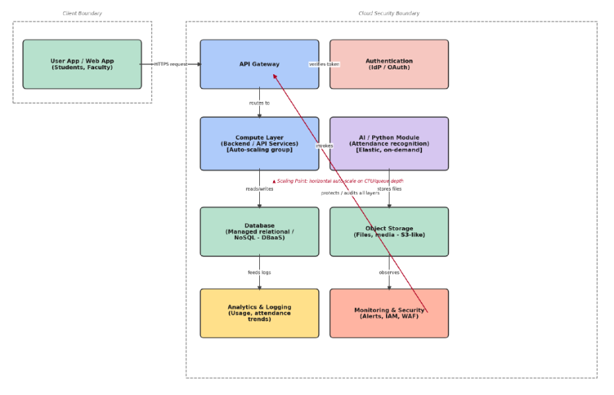
Figure 2: API Flow, Elasticity & Scalability Diagram for the Smart Campus Management System.
Task 4: Technical Justification
This section explains how the concept map and matrices above demonstrate CO1 — covering service model
selection, the role of APIs, elasticity, scalability, virtualization/managed-compute choices, and cloud
responsibility boundaries.
1. Effectiveness of the Concept Map in Representing Cloud Computing Principles
The concept map effectively represents cloud computing principles because it organizes the ecosystem
hierarchically: the central cloud ecosystem node branches into actors, service models, deployment models,
virtualization, and web services, all of which converge on the student's Project. The strongest design decisions are
(i) explicitly separating service models from deployment models, since they are frequently confused, and (ii)
placing scalability/elasticity as a connecting node between virtualization, the API gateway, and the Project, which
mirrors how these principles operate in a real system rather than as isolated theory.
2. Influence of Scalability, Elasticity, and Resource Management on the Architecture
Scalability, elasticity, and resource management directly shape the architecture: the compute layer is deployed as
an auto-scaling group so that additional instances are provisioned automatically when attendance requests spike
(for example, at the start of each class period), and released when demand falls, which keeps costs proportional to
actual usage. Resource pooling allows the database and storage layers to serve multiple campus departments from
shared infrastructure. If these capabilities were absent, the system would face several challenges:
●​ Fixed-capacity servers would either be over-provisioned (wasting cost) or under-provisioned (causing
slow response or downtime during peak attendance-marking periods).
●​ Sudden spikes in usage (e.g., examination result release) could crash the backend without elastic scaling.
●​ Manual resource management would slow down recovery from failures, reducing overall reliability.
3. Justification for the Selection of APIs, Web Services, and Cloud Services


REST APIs were selected for communication between the frontend, API gateway, and backend services because
REST is lightweight, stateless, and well suited to the JSON-based data exchanges used for attendance, fee, and
notice records. The API gateway centralizes authentication, rate-limiting, and routing, which simplifies the
addition of new modules. The chosen cloud services in Task 2B — managed database, object storage, serverless
notifications, and IaaS-based AI compute — were selected because each matches the specific technical need of its
module (structured data, unstructured files, event-driven alerts, and heavy computation respectively) rather than
using a single generic service for everything, which improves overall functionality and cost-efficiency.
4. Relationships Between Components and Their Effect on Reliability, Performance, and User Experience
The relationships mapped in Figure 1 and Figure 2 — such as the API gateway routing to the compute layer, the
compute layer reading/writing to the database, and monitoring observing all layers — directly improve system
quality. Because authentication is verified once at the gateway rather than in every module, the system reduces
redundant processing and potential security gaps, improving both performance and reliability. The monitoring
and logging component's connection to every layer enables early detection of failures, which reduces downtime
and improves user experience for students and faculty relying on the attendance and fee systems.
5. Reflection on Developing the Concept Map
Developing this concept map clarified how cloud computing concepts that are often taught separately — service
models, virtualization, APIs, and elasticity — function together as a connected system rather than as independent
topics. Mapping the Project onto these concepts made the shared-responsibility model concrete: it became clearer
which failures or bottlenecks would be the provider's responsibility versus the application team's responsibility. If
redesigning the map, it would be improved by adding a data-flow direction indicator on every link (not just
selected ones) and by including approximate latency or cost annotations at each scaling point, which would make
the trade-offs of each cloud service choice more explicit for future evaluation.
Expected Digital Evidence — README Summary
The | following | README | content | should | accompany | the | GitHub | repository | submission
(CSA15_CO1_AT2_192425341):
●​ Title: Smart Campus Management System — Cloud Architecture (CO1 Concept Mapping Assessment)
●​ Tools Used: draw.io / diagrams.net for diagrams; Microsoft Word for documentation; cloud provider
console (e.g., AWS/Azure/GCP, per availability) for reference service names.
●​ Repository Structure: /diagrams (concept_map.drawio, concept_map.png, api_flow.drawio,
api_flow.png), /docs (this DOCX/PDF), /matrices (Task 2A and 2B as exported tables), README.md
●​ CO1 Reflection: This assessment demonstrated applied understanding of cloud service models,
virtualization, web services, elasticity, and scalability by mapping each concept directly onto a working
Project architecture, fulfilling CO1's requirement to apply cloud computing technologies to develop a
cloud-based solution.

